**Adding HTML on Popups**

Note that if you want to have stylized text (bold, different fonts, etc) in the popup window you can use HTML. Here's an example: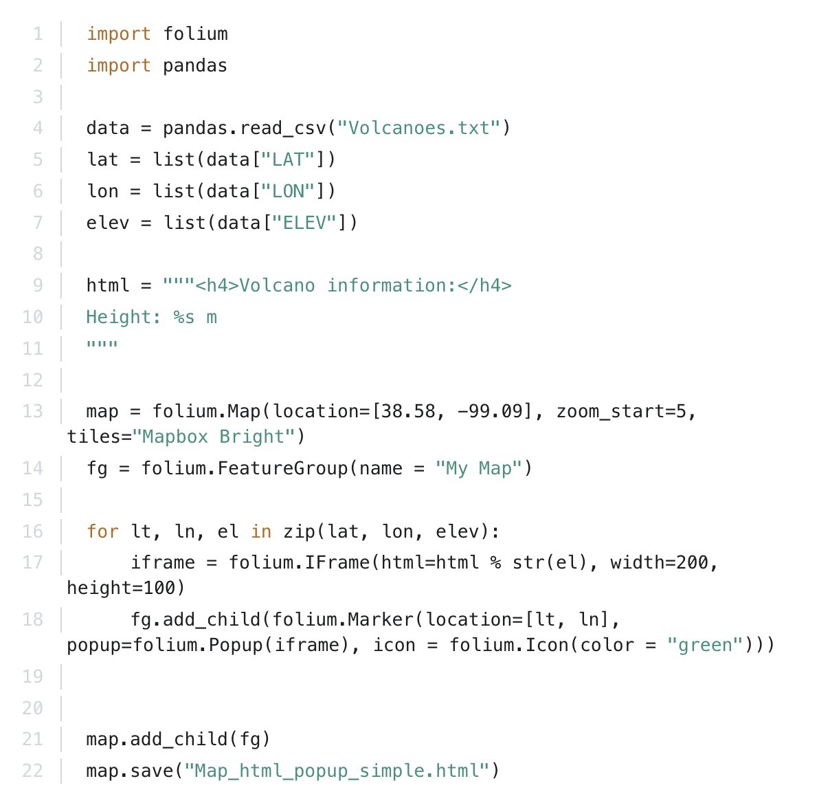

You can even put links in the popup window. For example, the code below will produce a popup window with the name of the volcano as a link which does a Google search for that particular volcano when clicked: